Nano N1021

Intel® Celeron® J4125 Quad Core processor
迷你主机

Features：
◇ All aluminum structure，fanless design；
◇ Onboard Intel Celeron J4125 Quad Core processor；
◇ Support 6*USB（4*USB3.0）；
◇ Support 3*M.2 Slot（Support WIFI+4G at the same time ）；
◇ Support synchronous and asynchronous three display，Support 4K Full HD；
◇ Support desktop, rail, VESA wall-mounted and other fixing methods
◇ Support OS：



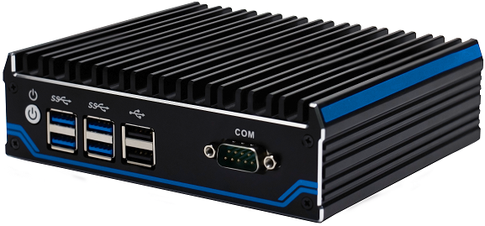
Specification
Model | Nano N1021
Color | Black (Color can be customized)
Material | High-quality all aluminum，surface anodic oxidation
Processor | Onboard Intel Celeron J4125（Quad core quad threading，4MB cache，2.0GHz，Max turbo 2.7GHz）
CPU Architecture | Gemini Lake Refresh
RAM | Support 1*DDR4 2400MHz SODIMM RAM Slot，MAX 8GB
BIOS | AMI UEFI BIOS
Display Chip | Integrated Intel HD Graphics 600
Display Port | 1*HDMI，2*DP（Support synchronous and asynchronous three display，Max Resolution support 4096x2160 @ 60Hz）
Front I/O | 1*Power Switch，4*USB3.0，2*USB2.0，1*COM
Rear I/O | 1*DC，1*HDMI，2*DP，2*Intel 1000M LAN，1*SIM Card Slot，1*Audio (support audio and mic input)
Expansion Slot | Support 1*M.2 2280 M-key Slot（Support SATA）
Expansion Slot | Support 1*M.2 2242 B-key Slot（Support4G），Embedded SIM slot
Expansion Slot | Support 1*M.2 2230 E-key Slot（Support WIFI、BT）
Expansion Slot | Expansion function: TPM Pin (support TPM 1.2 / 2.0 security module)，1*COM
Network | 2*10/100/1000M RTL8111H Ethernet Lan
Storage | 1*M.2 2280 Slot，Onboard 1*2.5”HDD
Input Voltage | Support DC 12V Input
Other Function | Auto power on when there is electricity、Timing boot、Wake on LAN、PXE boot、Watchdog（0～255 level
Work Temp | 0℃ ～ +50℃（Commercial HDD），-20℃ ～ +60℃（Industrial SSD），Surface air flow
Work Humidity | 0% ～ 95% non-condensing
Certificates | CE、 CCC、 FCC Class A、 ROHS
Dimension | 144 * 126.5 * 42 mm
Net Weight | 0.8 kg
Application | Industrial Automation, Medical, Logistics Transportation, Warehouse, Electronic Education, etc.
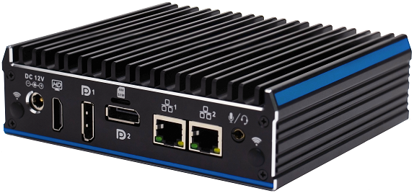
Accessories List
Name | Quantity | Specification
Power Adapter | 1 | Optional 12V 5A/ 12V 4A
Power Cord | 1 | Any Plug Optional  (China, US, EU, UK etc.)
VESA Bracket | 1 | Standard
Nano N1021 Drawing
Order Information
Configuration 1 | Nano N1021 | Intel Celeron J4125 | Standard Port

