IBOX-205 Plus

Features：
◇ All aluminum structure，fanless design；
◇ Support Intel Core i5 4300U dual core processor；
◇ Max. Support DDR3L 8G RAM；
◇ Support 1*MSATA Slot，1*2.5” HDD；
◇ Support WIFI/3G/4G（Choose one from three）；
◇ Support 6*COM（COM3 RS232/422/485 Optional）；
◇ Support OS：
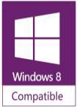
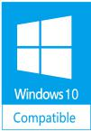



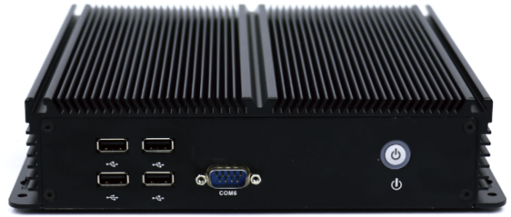
Specification
Model | IBOX-205 Plus
Color | Black（Color can be customized）
Material | High-quality all aluminum，surface anodic oxidation
Processor | Onboard Intel Core i5 4300U（dual core quad threading，1.9Ghz，Max. Turbo 2.9Ghz）；
RAM | Support 1*DDR3L 1333/1600MHz SODIMM RAM Slot，Max. Support 8GB
BIOS | AMI UEFI BIOS
Display Chip | Integrated Intel HD Graphics 4400
Display Port | 1*VGA，1*HDMI（Support synchronous and asynchronous dual display）
Front I/O | 4*USB2.0，1*COM，1*Power Switch；
Rear I/O | 2*USB3.0，5*COM（COM3 RS232/422/485 Optional），2*1000M LAN
Rear I/O | 1*VGA，1*HDMI，1*DC12V Input，1*Mic，1*Line Out
Expansion Slot | Support 1*MINI PCIE Slot（Support MSATA）；
Expansion Slot | Support 1*MINI PCIE Slot（WIFI/3G/4G Optional），Embedded SIM Slot；
Expansion Slot | Optional Ports：GPIO、LPT、PS/2 (Standard version doesn’t include these ports)
Network | 2*Intel i211-AT 1000M LAN
Storage | Support 1*MSATA Slot，1*2.5” HDD（2*2.5” HDD Optional）
Input Voltage | Support DC 12V Input
Other Function | Auto power on when there is electricity、Timing boot、Wake on LAN、PXE boot、Watchdog（0～255 level）(Standard version doesn’t set these function)
Work Temp | 0℃ ～ +50℃（Commercial HDD），-20℃ ～ +60℃（Industrial SSD），Surface air flow
Work Humidity | 0% ～ 95% non-condensing
Certificates | CE、 CCC、 FCC Class A、 ROHS
Dimension | 234 * 200 * 54mm
Net Weight | 2.0kg
Application | Industrial Automation, Medical, Logistics Transportation, Warehouse, Electronic Education etc.
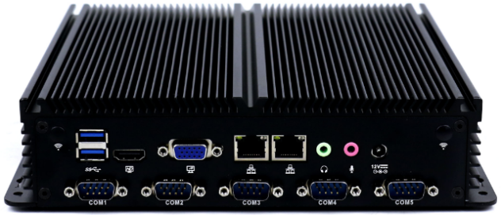
IBOX-205 Plus Drawing

Accessories List
Name | Quantity | Specification
Power Adapter | 1 | 12V 5A
Power Cord | 1 | Any Plug Optional  (China, US, EU, UK etc.)
CD Driver | 1 | Neutral
Order Information
Configuration 1 | IBOX-205 Plus | Intel Core i5 4300U | Standard Port
